DUY TAN UNIVERSITY
INTERNATIONAL SCHOOL



INDIVIDUAL CAPSTONE REPORT

CHACHA20 – A MODERN STREAM CIPHER FOR NETWORK SECURITY

COURSE | : | ELEMENTS OF NETWORK SECURITY
CLASS | : | CMU-CS 376 CIS
INSTRUCTOR | : | M.Sc. Lê Văn Tịnh
STUDENT | : | Đặng Khải Vy
STUDENT ID | : | 30209244459

Da Nang, …… September 2026

TABLE OF CONTENTS
PROJECT INFORMATION 4
REVISION HISTORY 4
CHAPTER 1: INTRODUCTION 6
1.1. Purpose of Document 6
1.2. Document Objectives 6
CHAPTER 2: MAIN DECISIONS TO CHOOSE TECHNOLOGIES 8
2.1. Selection Criteria 8
2.1.1. Cryptographic Implementation Capability 8
2.1.2 Support for a Controlled Network Environment 8
2.1.3 Network Traffic Analysis Capability 8
2.1.4 Security Analysis Capability 9
2.1.5 Performance Evaluation Capability 9
2.1.6 Compatibility with Virtual Machines 9
2.2 Technology Stack Table 10
2.2.1 Final Technology Architecture 11
CHAPTER 3: INDIVIDUAL ROLES & WORK BREAKDOWN STRUCTURE 12
3.1. Individual Roles 12
3.2. Work Breakdown Structure (WBS) 13
CHAPTER 4: CORE TECHNOLOGY SPECIFICATIONS 15
4.1. Operating Principles 15
4.1.1 Overview of ChaCha20 15
4.1.2 ChaCha20 Internal State 15
4.1.3 ARX Construction 16
4.1.4 The Quarter Round Function 16
4.1.5 ChaCha20 Rounds 17
4.1.6 Block Function and Keystream Generation 17
4.1.7 Encryption and Decryption Process 18
4.1.8 Key, Counter, and Nonce 18
4.1.9 Security Consequence of Nonce Reuse 18
4.1.10 ChaCha20 and Authentication 18
CHAPTER 5: SYSTEM ARCHITECTURE & IMPLEMENTATION 20
5.1. System and Network Topology 20
5.2. Implementation Steps 21
5.2.1. ChaCha20 Key and Nonce Configuration 22
5.2.2. Basic ChaCha20 Encryption and Decryption 22
5.2.3. RFC 8439 Test Vector Verification 23
5.2.4. Alice Client Implementation 24
5.2.5. Bob Server Implementation 25
5.3. Security Assessment 25
5.3.1. Security Assessment Scenario 1 – Encrypted Traffic Observation 25
5.3.2. Security Assessment Scenario 2 – ChaCha20 Nonce Reuse 27
5.3.3. Performance Assessment 28
5.3.4. Security Assessment Discussion 29
5.3.5. Chapter Summary 30
CHAPTER 6: CONCLUSION & FUTURE WORK 32
6.1. Conclusion 32
6.2. Future Work 33
CHAPTER 7: REFERENCES 34

LIST OF TABLES
Table 1: Technology Stack and Selection Rationale 7
Table 2: Project Work Breakdown Structure (WBS) 9
Table 3: ChaCha20 512-bit State Composition 10
Table 4: Virtual Laboratory Network Configuration 15
Table 5: Software Environment 17
Table 6: Security Assessment Results 23
Table 7: ChaCha20 and AES-256-CTR Benchmark Results 24
Table 8: Security Assessment Scenarios and Results 25
Table 9: Project Deliverables and Submission Status 30

LIST OF FIGURES
Figure 1: ChaCha20 512-bit Internal State Structure 11
Figure 2: ChaCha20 Virtual Laboratory Network Topology 16
Figure 3: Network Connectivity Verification Between Alice and Bob 16
Figure 4: Basic ChaCha20 Encryption and Decryption Verification 18
Figure 5: RFC 8439 ChaCha20 Test Vector Verification 19
Figure 6: Alice Client Encrypting and Sending ChaCha20 Ciphertex 20
Figure 7: Bob Successfully Receiving and Decrypting the ChaCha20 Message 20
Figure 8: Encrypted Application Data Observed in the TCP Stream 21
Figure 9: ChaCha20 Ciphertext Observed in a Captured TCP Packet 22
Figure 10: ChaCha20 Nonce Reuse Security Demonstration 23
Figure 11: ChaCha20 and AES-256-CTR Performance Benchmark 24

PROJECT INFORMATION
Field | Detail
Project Acronym | CC20 (ChaCha20-Poly1305)
Project Title | ChaCha20 – A Modern Stream Cipher for Network Security
Course | CMU-CS 376 – Elements of Network Security
GitHub / Demo Link | https://github.com/.......................................... (to be filled in)
Duration | 27/08/2026 (start date) – 17/09/2026 (end date)
Student Email | .......................................................@dtu.edu.vn
Contact Phone | 0792249784
Project Mentor | MSc. Le Van Tinh

REVISION HISTORY
Version | Date | Description | Author
Draft | 27/08/2026 | Defined the project scope and selected ChaCha20 as the core technology. Established the project objectives based on confidentiality and reviewed the internal mechanism, RFC 8439 specification, and planned the experimental laboratory and report structure. | Dang Khai Vy
v1.0 | 05/09/2026 | Built the experimental laboratory using a Windows 11 VM as Alice and a Kali Linux VM as Bob and the security-analysis environment on a VirtualBox Host-only network. Installed Python, the cryptography library, and Wireshark, and implemented the basic ChaCha20 encryption/decryption tests and RFC 8439 | Dang Khai Vy
v1.1 | 12/09/2026 | Completed the Alice–Bob encrypted communication, Wireshark packet capture, controlled nonce-reuse security demonstration, and ChaCha20 vs. AES-256-CTR performance benchmark. Updated the report based on the experimental results and documented the limitations of bare ChaCha20. | Dang Khai Vy
v2.0 | 17/09/2026 | Finalized the technical report, source-code deliverables, experimental results, figures, security assessment, conclusion, future work, and demonstration video for submission. | Dang Khai Vy

CHAPTER 1: INTRODUCTION

1.1. Purpose of Document
The purpose of this document is to provide a technical specification and practical evaluation of ChaCha20 as a modern stream cipher for network security. The document presents the technical basis for selecting ChaCha20, explains its cryptographic design and operating principles, and documents the implementation process in a controlled virtual laboratory environment.
The document also describes the configuration of the experimental environment, the implementation of ChaCha20-based encryption and decryption, and the communication process between two virtual machines. The laboratory uses a Windows 11 virtual machine as the sender (Alice) and a Kali Linux virtual machine as the receiver and security-analysis machine (Bob). The two machines communicate through an isolated VirtualBox Host-only network.
In addition to the theoretical study, this document records practical experiments used to evaluate the selected technology. These experiments include basic encryption and decryption, verification against an official ChaCha20 test vector, transmission of encrypted data between Alice and Bob, packet observation using Wireshark, a controlled demonstration of nonce reuse, and performance benchmarking between ChaCha20 and AES-256-CTR.
The document is intended to provide a complete record of the project's technical decisions, implementation procedures, experimental observations, and security considerations. The results are obtained from the controlled laboratory environment and are used to demonstrate the practical characteristics and limitations of ChaCha20 in the context of network security.

1.2. Document Objectives
The main objective of this project is to study and evaluate ChaCha20 as a modern stream cipher for network security through both theoretical analysis and practical implementation. The project focuses on understanding how ChaCha20 operates, how it can be applied to protect data during transmission, and what security considerations must be taken into account when using the algorithm.
The specific objectives of this project are:
- To study the cryptographic design of ChaCha20. The project aims to examine the internal structure of ChaCha20, including its 512-bit state, ARX (Add-Rotate-XOR) operations, quarter-round function, and 20-round transformation process.
- To understand the encryption and decryption mechanism. The project aims to demonstrate how ChaCha20 generates a keystream and combines it with plaintext using the XOR operation to produce ciphertext, as well as how the same process is used to recover the original plaintext during decryption.
- To implement ChaCha20 in a controlled laboratory environment. A practical implementation is developed using Python and the cryptography library. The implementation is tested using two isolated virtual machines representing Alice and Bob.
- To verify the correctness of the implementation. The project aims to verify that the implementation can correctly perform encryption and decryption and to compare the generated ciphertext with the official ChaCha20 test vector specified in RFC 8439.
- To demonstrate the use of ChaCha20 in network communication. The project implements a simple communication process in which Alice encrypts a message and sends the resulting ciphertext to Bob through a TCP connection over an isolated virtual network.
- To analyze encrypted network traffic. Wireshark is used to capture and examine the communication between Alice and Bob. This experiment demonstrates how encrypted application data appears when observed at the network level.
- To investigate the security implications of nonce reuse. A controlled experiment is conducted to demonstrate why the same nonce must not be reused with the same key for different plaintext messages. The experiment illustrates how keystream reuse can expose the relationship between plaintexts.
- To evaluate the practical performance of ChaCha20. The project measures the encryption throughput of ChaCha20 for different data sizes and compares the results with AES-256-CTR under the same laboratory environment.
- To identify the security scope and limitations of ChaCha20. The project distinguishes between confidentiality provided by the ChaCha20 stream cipher and additional security properties such as integrity and authentication that require an authenticated encryption construction such as ChaCha20-Poly1305.
Overall, these objectives provide a basis for evaluating ChaCha20 from both cryptographic and practical network-security perspectives, rather than treating the algorithm only as a theoretical encryption technique.

CHAPTER 2: MAIN DECISIONS TO CHOOSE TECHNOLOGIES

2.1. Selection Criteria
The selection of technologies for this project was based on the technical requirements of studying and experimentally evaluating the ChaCha20 stream cipher in a controlled network-security environment. Since the project focuses on cryptographic operation, secure data transmission, network observation, security analysis, and performance evaluation, the selected technologies need to support both implementation and practical experimentation.
The following criteria were considered when selecting the technologies used in the project.

2.1.1. Cryptographic Implementation Capability
The primary requirement is the ability to implement and test ChaCha20 correctly. The selected programming environment should provide reliable cryptographic primitives while allowing the project to demonstrate the encryption and decryption process.
Python was selected because it provides a straightforward development environment and has established cryptographic libraries. The cryptography library provides an implementation of ChaCha20 that can be used for practical encryption and decryption experiments without requiring the project to implement the low-level cryptographic primitive from scratch.
This approach allows the project to focus on understanding the algorithm, its parameters, and its security properties while reducing the possibility of introducing implementation errors into the underlying cryptographic operations.

2.1.2 Support for a Controlled Network Environment
The project requires communication between two separate machines so that ChaCha20 can be evaluated in a realistic data-transmission scenario. Therefore, the selected virtualization platform must allow multiple virtual machines to communicate through an isolated network.
VirtualBox was selected to create the experimental environment. The laboratory consists of a Windows 11 virtual machine acting as Alice and a Kali Linux virtual machine acting as Bob and the security-analysis machine. A Host-only network is used so that the communication remains inside the controlled laboratory environment.
The use of an isolated virtual network also makes it possible to capture network traffic safely with Wireshark without involving external systems.

2.1.3 Network Traffic Analysis Capability
Because one objective of the project is to examine how encrypted data appears during transmission, a network packet-analysis tool is required.
Wireshark was selected because it provides detailed packet-level visibility into network communication. It allows the project to identify the TCP connection between Alice and Bob and inspect the transmitted application data.
This is particularly useful for demonstrating the difference between plaintext communication and ciphertext transmission. Instead of only showing encryption results inside a Python program, the project can also observe the encrypted data at the network level.

2.1.4 Security Analysis Capability
The selected environment should support experiments that demonstrate important security considerations associated with stream ciphers.
In particular, the project includes a controlled nonce-reuse demonstration. Python is used to generate two ciphertexts using the same key and nonce, allowing the relationship between the corresponding plaintexts to be examined mathematically.
This experiment does not represent an attack against an external system. It is a controlled cryptographic demonstration designed to illustrate why nonce uniqueness is an important requirement when using ChaCha20.

2.1.5 Performance Evaluation Capability
The project also evaluates the practical processing performance of ChaCha20. Therefore, the selected programming environment needs to provide a consistent way to measure encryption time and calculate throughput for different amounts of data.
Python's timing facilities and the cryptography library provide sufficient functionality for this purpose. The benchmark measures ChaCha20 performance for several data sizes and compares the results with AES-256-CTR under the same laboratory environment.

2.1.6 Compatibility with Virtual Machines
Another consideration is compatibility with the available virtual machines. The selected technologies should operate reliably on both Windows and Linux so that the same cryptographic concept can be demonstrated across different operating systems.
The final environment uses:
- Windows 11 as the Alice client.
- Kali Linux as the Bob server and analysis environment.
- VirtualBox Host-only networking for isolated communication.
- Python for implementation and testing.
- cryptography for cryptographic operations.
- Wireshark for network traffic analysis.
The physical host machine is not used as a communication endpoint in the experiment. Its role is limited to providing the virtualization environment and Host-only network infrastructure.

2.2 Technology Stack Table

Table 1: Technology Stack and Selection Rationale
Category | Technology | Role in the Project | Reason for Selection
Virtualization | VirtualBox | Creates and manages the laboratory virtual machines | Provides an isolated and reproducible VM environment
Operating System | Windows 11 | Alice/client machine | Provides the sender-side environment for encryption
Operating System | Kali Linux | Bob/server and security-analysis machine | Provides the receiver and network-analysis environment
Network | VirtualBox Host-only Network | Connects Alice and Bob | Keeps experimental communication isolated
Programming Language | Python | Implements experiments and benchmarks | Simple syntax and suitable cryptographic libraries
Cryptographic Library | Python cryptography | Provides ChaCha20 and AES cryptographic primitives | Reliable library for practical cryptographic experiments
Network Protocol | TCP | Transfers ciphertext from Alice to Bob | Provides a simple and observable communication channel
Network Analysis | Wireshark |  | Enables packet-level observation of encrypted traffic
  Captures and examines network packets
Reference Standard | RFC 8439 | Provides ChaCha20 specifications and test vectors | Used to verify implementation correctness
Performance Testing | Python timing functions | Measures encryption execution time | Enables throughput calculation for different data sizes

2.2.1 Final Technology Architecture
The selected technologies work together as a small controlled experimental system. Windows 11 performs the client-side encryption, while Kali Linux receives and decrypts the ciphertext. The communication takes place through the isolated Host-only network.
Kali Linux additionally provides the environment for network traffic analysis and cryptographic experiments such as nonce reuse and performance benchmarking. This allows several aspects of ChaCha20 to be evaluated without requiring a large or complicated network infrastructure.
The overall technology relationship can therefore be summarized as:
VirtualBox → Windows 11 (Alice) → ChaCha20 Encryption → Host-only Network → Kali Linux (Bob) → ChaCha20 Decryption
with Wireshark operating on the Kali Linux side to observe the network traffic.

CHAPTER 3: INDIVIDUAL ROLES & WORK BREAKDOWN STRUCTURE

3.1. Individual Roles
As this is an individual capstone project, the student is responsible for the complete project lifecycle. The responsibilities include researching the ChaCha20 algorithm and relevant security concepts, selecting the technologies and designing the experimental environment, implementing the encryption and communication components, conducting security and performance experiments, analyzing the results, and preparing the final technical report and demonstration materials.

3.2. Work Breakdown Structure (WBS)
The project work is divided into the following major phases:
Table 2: Project Work Breakdown Structure (WBS)
Phase | Main Activities | Expected Output
Phase 1 – Research | Study ChaCha20, stream ciphers, ARX, RFC 8439, nonce requirements | Technical background and requirements
Phase 2 – Technology Selection | Select VirtualBox, Windows 11, Kali Linux, Python, cryptography, Wireshark | Final technology stack
Phase 3 – Laboratory Setup | Configure VMs, Host-only network, static IP addresses, connectivity | Functional isolated laboratory
Phase 4 – Basic Implementation | Implement encryption/decryption tests | Successful basic ChaCha20 test
Phase 5 – Correctness Verification | Test against RFC 8439 vector
  Verified implementation
Phase 6 – Network Communication | Implement Alice client and Bob server | Successful encrypted Alice-to-Bob communication
Phase 7 – Network Analysis | Capture and inspect traffic using Wireshark | Evidence of encrypted network transmission
Phase 8 – Security Demonstration | Perform controlled nonce-reuse experiment | Demonstration of nonce-reuse consequence
Phase 9 – Performance Evaluation | Benchmark ChaCha20 and AES-256-CTR | Performance measurements and comparison
Phase 10 – Documentation | Analyze results and prepare final report | Completed technical report

CHAPTER 4: CORE TECHNOLOGY SPECIFICATIONS

4.1. Operating Principles

4.1.1 Overview of ChaCha20
ChaCha20 is a symmetric stream cipher designed by Daniel J. Bernstein. It belongs to the family of ARX-based cryptographic algorithms, where Addition modulo $2^{32}$, Rotation, and XOR operations are used as the fundamental building blocks.
Unlike a block cipher such as AES, which processes data through a block-oriented transformation, ChaCha20 generates a pseudorandom keystream and combines the keystream with plaintext using the XOR operation. The same keystream-generation process is used during decryption, allowing the ciphertext to be converted back into the original plaintext.
The basic encryption relationship can be represented as:
C = P ⊕ K
where:
- P = plaintext
- C = ciphertext
- K = ChaCha20 keystream
- ⊕ = XOR operation
Because XOR is reversible, decryption follows:
P=C⊕K
Therefore, the security of ChaCha20 depends on the unpredictability of the generated keystream and the correct management of the secret key, counter, and nonce.

4.1.2 ChaCha20 Internal State
ChaCha20 operates on a 512-bit internal state, represented as a matrix of sixteen 32-bit words.
The state contains four groups of information:
Table 3: ChaCha20 512-bit State Composition
State Component | Number of 32-bit Words | Purpose
Constant | 4 | Fixed words defining the ChaCha20 construction
Key | 8 | 256-bit secret key
Counter | 1 | Identifies the position of the keystream block
Nonce | 3 | 96-bit unique value associated with the encryption operation
Total | 16 | 512-bit state
The conceptual state can be represented as:
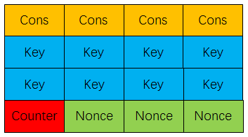
Figure 1: ChaCha20 512-bit Internal State Structure
Each cell represents one 32-bit word.
The use of a fixed-size internal state allows ChaCha20 to perform repeated transformations on the state and generate a pseudorandom output block. These output blocks form the keystream used for encryption.

4.1.3 ARX Construction
The main cryptographic operations used by ChaCha20 are based on the ARX construction:
- A – Addition: addition modulo $2^{32}$,
- R – Rotation: cyclic rotation of bits within a 32-bit word
- X – XOR: exclusive OR between two words
A simplified sequence of ARX operations can be represented as:
a = a + b
d = d ⊕ a
d = ROTL (d,r)
where ROTL represents a left rotation by a specified number of bit positions.
ARX operations have several useful characteristics for software cryptography. They are simple arithmetic and logical operations that are available directly on common processors. ChaCha20 therefore does not require a substitution table such as the AES S-box for its basic transformation.

4.1.4 The Quarter Round Function
The quarter round is the fundamental transformation used by ChaCha20. It operates on four 32-bit words, conventionally represented as aa, bb, cc, and dd.
The quarter-round transformation consists of four main stages:
a=a+b
d=d⊕a
d=ROTL(d,16)
c=c+d
b=b⊕c
b=ROTL(b,12)
a=a+b
d=d⊕a
d=ROTL(d,8)
c=c+d
b=b⊕c
b=ROTL(b,7)
These operations provide diffusion and mixing among the words of the internal state.
The quarter round is applied repeatedly to different combinations of the sixteen state words. This allows changes in individual input words to influence a much larger portion of the resulting state.

4.1.5 ChaCha20 Rounds
ChaCha20 performs 20 rounds of transformation. These rounds are organized as 10 double rounds, with each double round consisting of:
- One column round
- One diagonal round
During the column round, quarter-round operations are applied to words arranged in the columns of the 4×4 state matrix.
During the diagonal round, the quarter-round operations are applied according to the diagonal arrangement of the state.
The alternating column and diagonal transformations ensure that information is repeatedly mixed across different parts of the internal state.
The overall structure can therefore be summarized as:
Initial State → 10 Double Rounds → Add Initial State → Serialize → Keystream Block
This repeated transformation is the core process used to generate ChaCha20's pseudorandom keystream.

4.1.6 Block Function and Keystream Generation
ChaCha20 generates its output in blocks. For each block, the algorithm starts with an initial 512-bit state containing the constant, key, counter, and nonce.
The state is then transformed through the 20-round operation. After the rounds are completed, the resulting state is added word-by-word to the original initial state. The resulting 512-bit value is serialized into 64 bytes.
This output forms one 64-byte keystream block.
For longer plaintexts, the counter is incremented and another ChaCha20 block is generated. The resulting keystream blocks are concatenated and used to encrypt the plaintext.
Therefore:
Key + Counter + Nonce → ChaCha20 Block Function → Keystream → XOR with Plaintext → Ciphertext

4.1.7 Encryption and Decryption Process
During encryption, the plaintext is combined with the generated keystream using XOR.
Ci=Pi⊕Ki
During decryption, the ciphertext is combined with the same keystream:
Pi=Ci⊕Ki
The same key, nonce, and corresponding counter position must therefore be available to reproduce the same keystream.
In the project implementation, Alice generates the ciphertext using ChaCha20 and sends the encrypted data to Bob. Bob uses the corresponding key and nonce to regenerate the required keystream and recover the original plaintext.

4.1.8 Key, Counter, and Nonce
ChaCha20 uses a 256-bit key, represented by 32 bytes. The key is the secret cryptographic value and must be protected from unauthorized disclosure.
The algorithm also uses a counter to identify the position of a keystream block. In the RFC 8439 construction used by the project, ChaCha20 uses a 32-bit block counter together with a 96-bit nonce.
The nonce is not intended to be secret. However, it must be managed correctly. In particular, the same key and nonce combination must not be reused for different plaintexts.

4.1.9 Security Consequence of Nonce Reuse
Suppose two plaintext messages P1P_1 and P2P_2 are encrypted using the same key and nonce. If the same keystream KK is generated, the ciphertexts become:
C1=P1⊕K
C2=P2⊕K
XORing the two ciphertexts gives:
C1⊕C2=P1⊕K⊕P2⊕K
Since:
K⊕K=0
the relationship becomes:
C1⊕C2=P1⊕P2
This does not mean that the entire plaintext is automatically revealed. However, it exposes a direct mathematical relationship between the two plaintexts and can significantly weaken confidentiality, especially when some plaintext information is known or predictable.
The project includes a controlled experiment to demonstrate this weakness using two messages encrypted with the same key and nonce.

4.1.10 ChaCha20 and Authentication
It is important to distinguish ChaCha20 from ChaCha20-Poly1305.
ChaCha20 is a stream cipher that primarily provides confidentiality. By itself, it does not provide an authentication tag for detecting unauthorized modification of ciphertext.
ChaCha20-Poly1305 combines ChaCha20 encryption with the Poly1305 message authentication algorithm to provide an authenticated-encryption construction. This provides both confidentiality and integrity/authentication when used correctly.
This distinction is important in the project because the practical implementation focuses on the bare ChaCha20 cipher. Therefore, the project does not claim that the basic ChaCha20 implementation independently provides message integrity or authentication.

CHAPTER 5: SYSTEM ARCHITECTURE & IMPLEMENTATION

5.1. System and Network Topology
The ChaCha20 experimental environment was designed as an isolated virtual laboratory using VirtualBox. The purpose of the topology is to provide a controlled environment in which encrypted communication can be implemented, observed, and evaluated without involving external systems.
The laboratory consists of two virtual machines connected through a VirtualBox Host-only network named malware_lab.
The main components are:
- Alice – Windows 11 Virtual Machine: acts as the sender. Alice prepares the plaintext, encrypts it using ChaCha20, and sends the nonce and ciphertext to Bob through TCP.
- Bob – Kali Linux Virtual Machine: acts as the receiver and security analysis machine. Bob receives the encrypted data, decrypts it using the shared key, and performs network traffic analysis and security experiments.
- Physical Windows Host: provides the Host-only network infrastructure through VirtualBox. It is not a participant in the Alice–Bob encrypted communication.
The final addressing configuration is shown in Table 5.1.

Table 4: Virtual Laboratory Network Configuration
Component | Operating System | IP Address | Role
Alice | Windowns 11 VM | 192.168.56.20 | Plaintext preparation, ChaCha20 encryption, message transmission
Bob | Kali Linux VM | 192.168.56.10 | Message reception, ChaCha20 decryption, security analysis
Host-only Adapter | Physical Windows Host | 192.168.56.1 | VirtualBox Host-only network infrastructure
Network | malware-lab | 192.168.56.0/24 | Isolated communication network

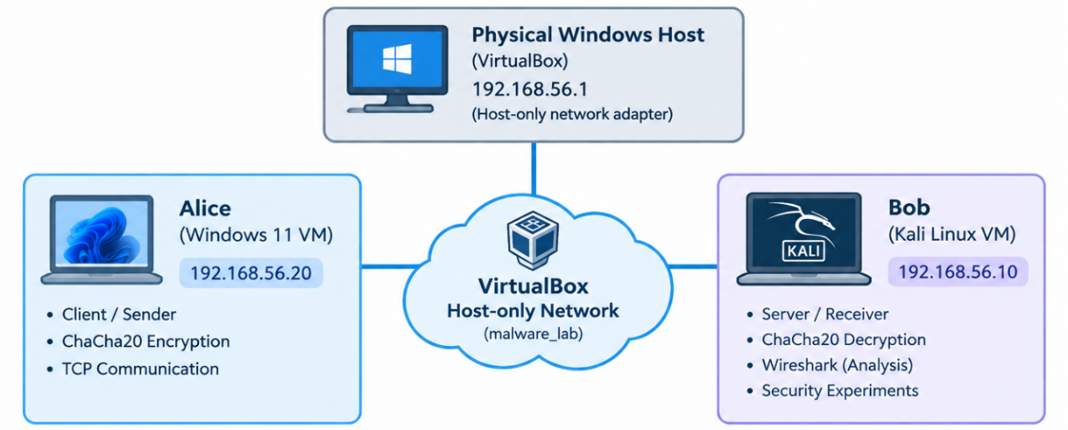
Figure 2: ChaCha20 Virtual Laboratory Network Topology

Before conducting the cryptographic experiments, network connectivity between Alice and Bob was verified using the ping command. The successful communication confirmed that both virtual machines were correctly connected to the Host-only network.

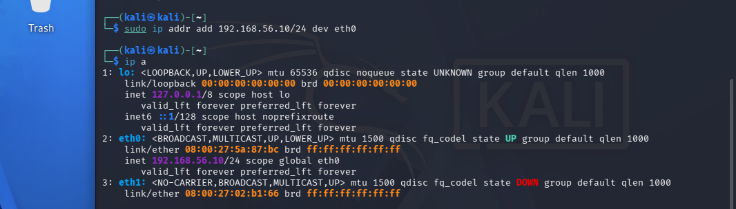

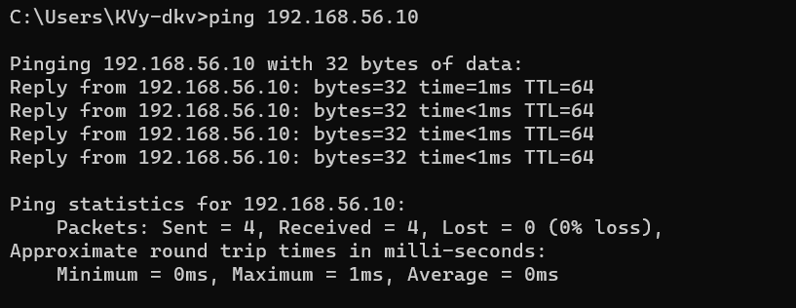
Figure 3: Network Connectivity Verification Between Alice and Bob

5.2. Implementation Steps
The implementation was developed using Python and the cryptography library. The low-level ChaCha20 primitive was selected to demonstrate the operation of the stream cipher directly.
Table 5: Software Environment
Component | Version / Configuration
Virtualization | VirtualBox
Alice OS | Windows 11
Bob OS | Kali Linux 2026.2
Python - Alice | 3.14.6
Python - Bob | 3.13.12
Cryptography - Alice | 50.0.1
Cryptography - Bob | 46.0.7
Network | VirtualBox Host-only
Network Name | malware−lab
TCP Port | 5000

5.2.1. ChaCha20 Key and Nonce Configuration
The experiment uses a 256-bit ChaCha20 key:
000102030405060708090a0b0c0d0e0f
101112131415161718191a1b1c1d1e1f
For the low-level ChaCha20 implementation used in the Python cryptography library, the 16-byte input consists of a 4-byte counter followed by a 12-byte nonce.
The network communication experiment uses counter value 1 and generates a fresh random 12-byte nonce for each encryption operation.
The resulting structure is:
4-byte counter + 12-byte nonce
The nonce is transmitted to Bob together with the ciphertext because Bob needs the same nonce to perform decryption. The nonce does not need to be secret; however, it must not be reused with the same key for different plaintext messages.

5.2.2. Basic ChaCha20 Encryption and Decryption
The first implementation test was performed locally before introducing network communication.
The test encrypts a plaintext using ChaCha20 and subsequently decrypts the generated ciphertext using the same key and nonce. The decrypted result is then compared with the original plaintext.
A successful result confirms that the basic encryption and decryption operations work correctly.

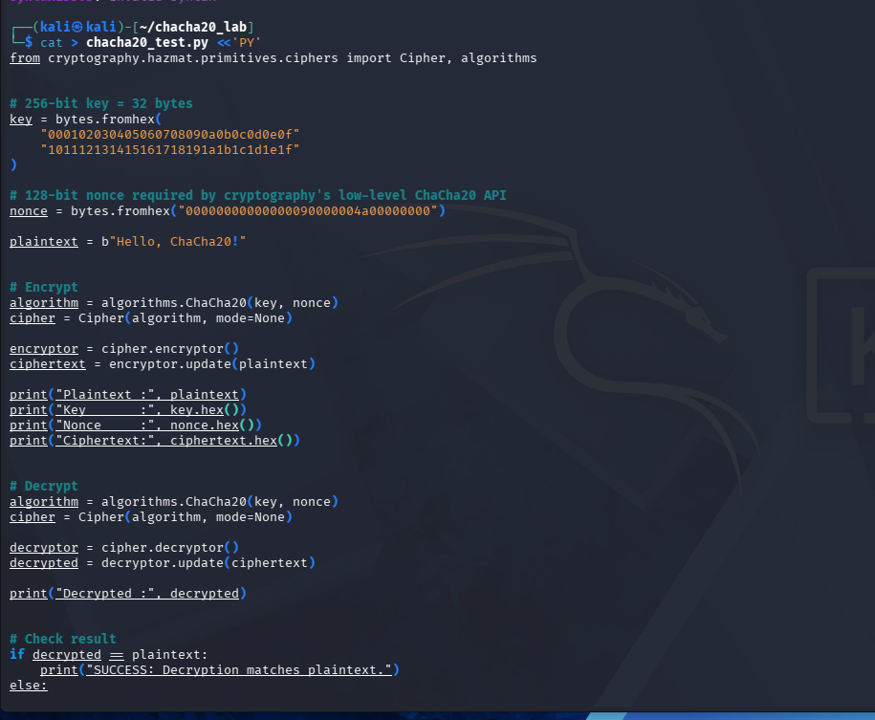
Figure 4: Basic ChaCha20 Encryption and Decryption Verification

5.2.3. RFC 8439 Test Vector Verification
After the basic test, the implementation was verified against the ChaCha20 test vector specified in RFC 8439.
The test uses the standardized key, counter, nonce, plaintext, and expected ciphertext. The 16-byte value supplied to the Python implementation is:
01000000000000000000004a00000000
where:
01000000
represents the initial counter value 1, and:
000000000000004a00000000
represents the 96-bit nonce.
The generated ciphertext was compared byte-by-byte against the expected RFC 8439 ciphertext.
The final result was:
PASS: Ciphertext matches RFC 8439.
The actual and expected ciphertext values were identical, and both had a length of 114 bytes.

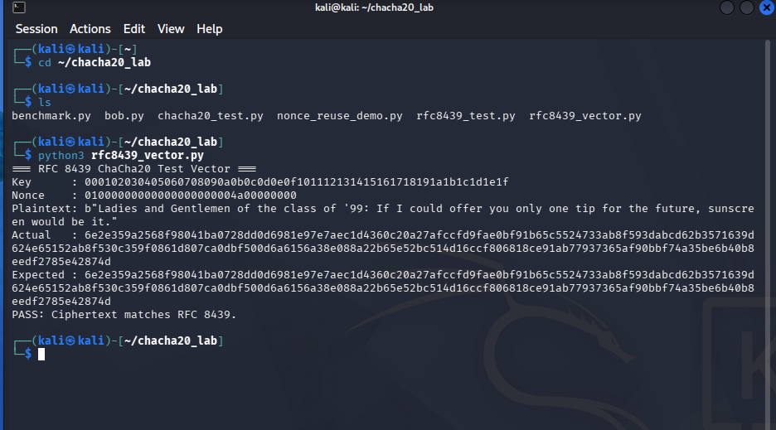
Figure 5: RFC 8439 ChaCha20 Test Vector Verification
This result provides standardized evidence that the ChaCha20 primitive used in the implementation produces the expected output for the official test vector.

5.2.4. Alice Client Implementation
The Windows 11 VM was configured as the Alice client.
The Alice program performs the following sequence:
- Defines the shared 256-bit ChaCha20 key.
- Prepares the plaintext message.
- Generates a random 12-byte nonce.
- Combines the counter and nonce.
- Encrypts the plaintext using ChaCha20.
- Creates a TCP connection to Bob at 192.168.56.10:5000.
- Sends the nonce.
- Sends the ciphertext.
- Closes the connection.
The plaintext used during the experiment was:
Hello Bob! This message is protected by ChaCha20.
The actual execution produced the following result:
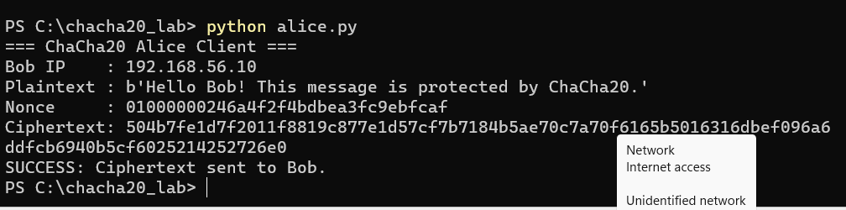
Figure 6: Alice Client Encrypting and Sending ChaCha20 Ciphertex
The result confirms that Alice successfully encrypted the plaintext and transmitted the resulting ciphertext to Bob.

5.2.5. Bob Server Implementation
The Kali Linux VM was configured as the Bob server.
Bob listens for TCP connections on:
192.168.56.10:5000
After receiving the connection, Bob obtains the nonce and ciphertext. The same shared key and received nonce are then used to initialize the ChaCha20 decryptor.
The actual result was:
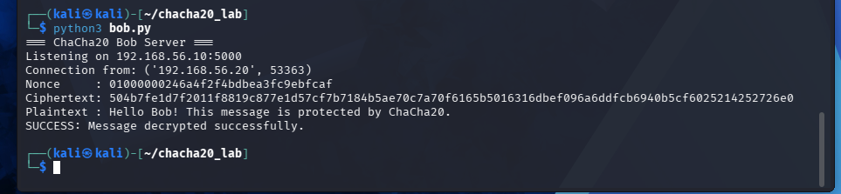
Figure 7: Bob Successfully Receiving and Decrypting the ChaCha20 Message
The recovered plaintext is identical to the original message generated by Alice, confirming successful end-to-end encryption and decryption within the virtual network.

5.3. Security Assessment
Unlike a malware or intrusion-detection project, the ChaCha20 project does not focus on reconnaissance, SYN flooding, or web exploitation. Therefore, the security assessment was designed around the main security properties and potential weaknesses of ChaCha20 that could be demonstrated safely within the isolated laboratory.
Three practical scenarios were evaluated:
- Observation of encrypted network traffic.
- Controlled nonce-reuse experiment.
- Performance evaluation.
These scenarios allow the project to assess both the intended security behavior and an important misuse condition of the stream cipher.

5.3.1. Security Assessment Scenario 1 – Encrypted Traffic Observation
After Alice transmitted the encrypted message to Bob, Wireshark was used on the Kali Linux VM to capture the TCP traffic.
The following display filter was used:
tcp.port : 5000
The captured traffic showed packets exchanged between:
Source : 192.168.56.20
Destination : 192.168.56.10
TCP Port : 5000
The application data contained binary ciphertext rather than the original plaintext.
Using Wireshark's Follow → TCP Stream feature, the application data appeared as unreadable binary characters.
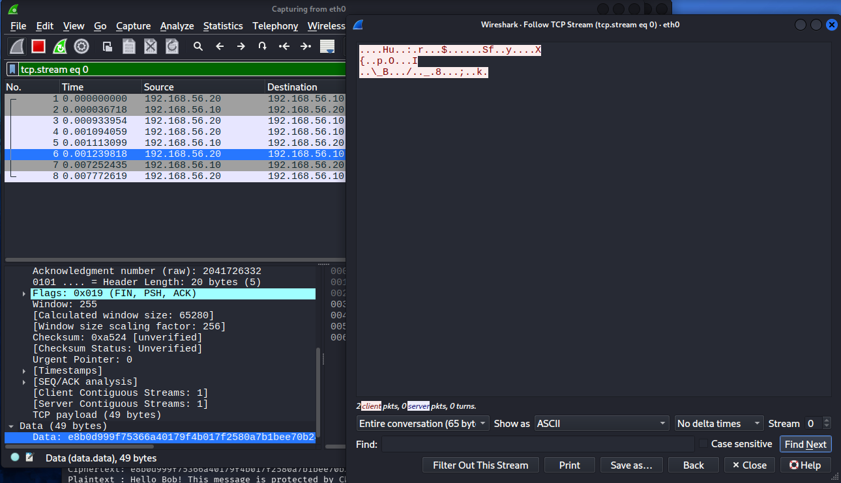
Figure 8: Encrypted Application Data Observed in the TCP Stream

A captured packet was also inspected at the hexadecimal level.
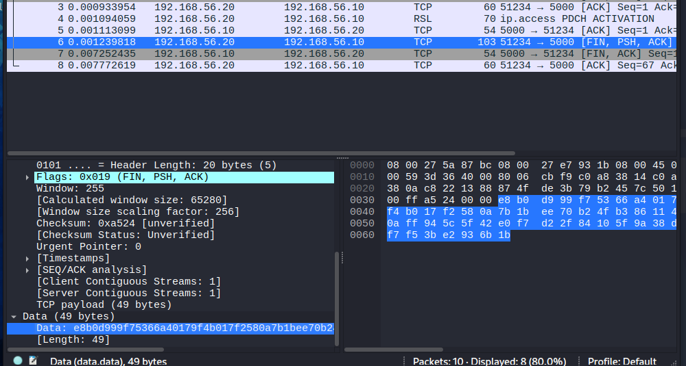
Figure 9: ChaCha20 Ciphertext Observed in a Captured TCP Packet
The result demonstrates that the plaintext message was not directly exposed in the application payload. However, network metadata such as IP addresses, TCP ports, packet sizes, and timing can still be observed. ChaCha20 protects the message content but does not conceal network metadata.

5.3.2. Security Assessment Scenario 2 – ChaCha20 Nonce Reuse
A controlled nonce-reuse experiment was performed to demonstrate the consequence of using the same nonce with the same key for multiple plaintext messages.
Two different plaintext messages were encrypted using the same key and the same nonce:
Plaintext 1: Attack at dawn! Send backup.
Plaintext 2: Attack at dusk! Send backup.
The experiment generated:
Ciphertext 1:
595a67ecdbb963119e188c42fed22ef78918564da6097e33f4100b0e
Ciphertext 2:
595a67ecdbb963119e188c56fad72ef78918564da6097e33f4100b0e
The XOR operation between the two ciphertexts produced the same result as the XOR operation between the corresponding plaintexts:
C1 XOR C2:
00000000000000000000001404050000000000000000000000000000
P1 XOR P2:
00000000000000000000001404050000000000000000000000000000
This relationship occurs because a stream cipher uses the same keystream when the same key and nonce are reused. In simplified form:
C1 = P1 XOR K
C2 = P2 XOR K
Therefore:
C1 XOR C2 = P1 XOR P2
The experiment further recovered the second plaintext using the first known plaintext:
P2 = C1 XOR C2 XOR P1
The recovered result was:
b'Attack at dusk! Send backup.'

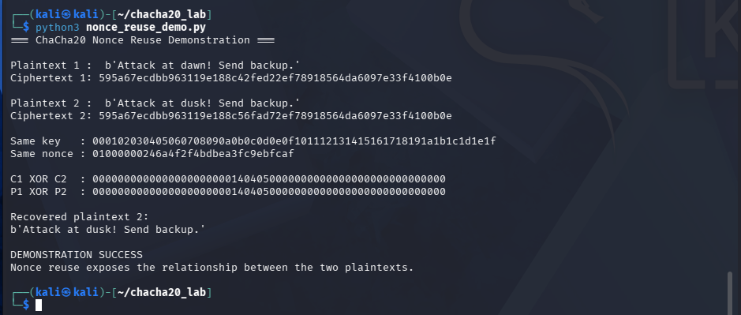
Figure 10: ChaCha20 Nonce Reuse Security Demonstration

Table 6: Security Assessment Results
Scenario | Test Method | Observed Result | Security Implication
Encrypted traffic observation | Wireshark TCP capture | Application payload appeared as ciphertext | Plaintext was not directly visible
Nonce reuse | Same key and nonce used for two messages | C1 XOR C2 = P1 XOR P2 | Reusing a nonce compromises confidentiality relationships
RFC 8439 verification | Compare actual and expected ciphertext | PASS | Implementation matches the standardized test vector
Performance | ChaCha20 vs AES-256-CTR benchmark | Throughput varied by data size | Performance depends on the execution environment and workload

5.3.3. Performance Assessment
A performance benchmark was conducted to compare ChaCha20 and AES-256-CTR using several data sizes.

Table 7: ChaCha20 and AES-256-CTR Benchmark Results
Data Size | ChaCha20 (MB/s) | AES-256-CTR (MB/s)
1 KB | 396.65 | 843.32
10 KB | 1697.78 | 2200.46
100 KB | 886.91 | 1215.72
1 MB | 322.42 | 293.75
10 MB | 341.50 | 1351.77

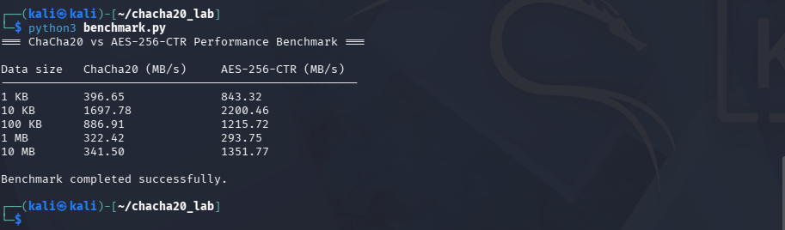
Figure 11: ChaCha20 and AES-256-CTR Performance Benchmark

The benchmark results varied according to the tested data size. In this particular laboratory environment, AES-256-CTR achieved higher throughput for 1 KB, 10 KB, 100 KB, and 10 MB, while ChaCha20 achieved slightly higher throughput for the 1 MB test.
These results should be interpreted as measurements from the specific virtualized environment rather than as a universal performance comparison. Factors such as processor architecture, virtualization overhead, operating-system scheduling, cryptographic library implementation, memory behavior, and benchmark methodology can affect the measured throughput.

5.3.4. Security Assessment Discussion
The experimental results demonstrate several important characteristics of the implemented ChaCha20 system.
First, the RFC 8439 test-vector verification produced an exact ciphertext match. This provides standardized evidence that the cryptographic primitive used in the experiment operates correctly for the tested vector.
Second, the Alice–Bob experiment demonstrated successful encrypted communication over the isolated TCP network. Alice generated the ciphertext and Bob successfully recovered the original plaintext using the corresponding key and nonce.
Third, Wireshark analysis demonstrated that the application payload observed during transmission was ciphertext rather than readable plaintext. Nevertheless, encryption does not hide network-level metadata such as source and destination addresses or TCP port information.
Finally, the nonce-reuse experiment demonstrated a significant limitation of stream-cipher usage. ChaCha20 requires correct nonce management; reusing the same nonce with the same key for different plaintexts exposes relationships between the plaintexts.
The current implementation uses bare ChaCha20, so it provides confidentiality but does not itself provide message authentication or integrity protection. For a production secure-communication system, an authenticated encryption construction such as ChaCha20-Poly1305 would need to be considered.

Table 8: Security Assessment Scenarios and Results
No. | Security Assessment Scenario | Method | Result
1 | RFC 8439 Test Vector Validation | Encrypt the plaintext using the key, counter, and nonce specified in RFC 8439 §2.4.2, then compare the ciphertext with the published reference value. | PASS – The generated ciphertext exactly matches the RFC 8439 reference.
2 | Nonce-Reuse Security Demonstration | Encrypt two different plaintexts using the same key and nonce, then apply XOR to the two ciphertexts and demonstrate plaintext recovery in the controlled lab. | SUCCESS – The relationship between the two plaintexts was exposed and the second plaintext was recovered.
3 | Alice–Bob Encrypted Communication | Alice encrypts a message and sends the nonce and ciphertext to Bob through the isolated Host-only network. Bob decrypts the received ciphertext using the shared key. | SUCCESS – Bob correctly recovered the original plaintext.
4 | Wireshark Packet Capture | Capture the TCP communication between Alice and Bob and inspect the transmitted application data. | SUCCESS – The captured payload appeared as binary/hexadecimal ciphertext rather than readable plaintext.
5 | ChaCha20 vs AES-256-CTR Benchmark | Measure encryption performance for data sizes from 1 KB to 10 MB under the same lab environment. | COMPLETED – Performance varied depending on the tested data size and algorithm.

The security assessment demonstrates both the functional correctness and an important security limitation of the implemented ChaCha20 system. The RFC 8439 test vector verification confirms that the implementation produces the expected ciphertext. The Alice–Bob experiment demonstrates successful encrypted communication, while Wireshark inspection shows that the transmitted application data is not directly readable as plaintext. The nonce-reuse experiment further demonstrates that reusing the same key and nonce can expose the relationship between plaintexts and enable plaintext recovery when one plaintext is known. Therefore, nonce uniqueness is an essential security requirement when using ChaCha20.

5.3.5. Chapter Summary
This chapter presented the architecture, implementation, and security assessment of the ChaCha20-based communication system.
The experimental environment consisted of a Windows 11 Alice virtual machine and a Kali Linux Bob/security-analysis virtual machine connected through the isolated malware_lab Host-only network.
The implementation was first verified through basic encryption and decryption and was subsequently validated against the RFC 8439 ChaCha20 test vector. The official test-vector experiment produced an exact ciphertext match.
The Alice–Bob communication experiment demonstrated successful encrypted message transmission over TCP, while Wireshark analysis confirmed that the application payload observed on the network was ciphertext rather than plaintext.
The security assessment further demonstrated the consequences of nonce reuse and measured the performance of ChaCha20 compared with AES-256-CTR under the laboratory environment.
These experiments provide practical evidence of ChaCha20's confidentiality function while also demonstrating the importance of correct nonce management and the distinction between encryption and authenticated encryption.

CHAPTER 6: CONCLUSION & FUTURE WORK

6.1. Conclusion
Measured against the objectives defined in Chapter 1, this project achieved the following results:
- Provided a complete description of ChaCha20's internal mechanism as specified in IETF RFC 8439, including the 4×4-word state matrix, the Quarter Round function, the ARX operations, and the 20-round transformation process.
- Implemented and verified ChaCha20 encryption and decryption using Python and the cryptography library. The implementation was tested using both a basic encryption/decryption experiment and an official RFC 8439 test vector. The generated ciphertext matched the reference ciphertext specified in RFC 8439 §2.4.2.
- Successfully deployed an isolated Alice–Bob experimental topology using a Windows 11 virtual machine as Alice and a Kali Linux virtual machine as Bob and the security-analysis environment. Both virtual machines communicated through a VirtualBox Host-only network, allowing the encryption and decryption process to be tested in a controlled environment.
- Successfully demonstrated encrypted communication between Alice and Bob. Alice encrypted a plaintext message using ChaCha20 and transmitted the nonce and ciphertext through the TCP connection. Bob successfully received the data and recovered the original plaintext using the shared key.
- Captured and analyzed the encrypted network traffic using Wireshark. The captured TCP stream contained binary/hexadecimal ciphertext rather than the original readable plaintext, demonstrating the confidentiality effect of encryption at the application-data level.
- Demonstrated the security risk of nonce reuse through a controlled experiment in which two different plaintexts were encrypted using the same key and nonce. By applying XOR operations to the ciphertexts and using one known plaintext, the second plaintext could be recovered. This experiment highlights the importance of never reusing a nonce with the same key.
- Conducted a quantitative performance comparison between ChaCha20 and AES-256-CTR using data sizes from 1 KB to 10 MB. The results showed that performance varied according to the tested data size and execution environment. ChaCha20 was faster at 1 MB in the conducted experiment, while AES-256-CTR achieved higher throughput for the other tested sizes.
Overall, the project fulfilled the main theoretical and experimental objectives established at the beginning of the project. The work combined an examination of the ChaCha20 algorithm with practical implementation, RFC-based verification, encrypted network communication, Wireshark traffic analysis, nonce-reuse security analysis, and performance benchmarking. These experiments provided a practical understanding of both the capabilities and security requirements of ChaCha20 as a modern stream cipher for network security.

6.2. Future Work
Several extensions can be considered to improve the current project:
- Extend the experimental environment to a physical network and repeat the communication and performance experiments outside the virtualized environment. This would provide additional results under different hardware and network conditions.
- Investigate authenticated encryption using ChaCha20-Poly1305. The current project focuses on the bare ChaCha20 stream cipher, which provides confidentiality but does not provide authentication or integrity protection. Future work could implement ChaCha20-Poly1305 and conduct controlled ciphertext-tampering experiments to evaluate authentication and integrity protection.
- Improve the network communication implementation by introducing robust message framing, explicit length handling, and appropriate error handling. This would make the Alice–Bob communication model more suitable for a larger experimental application.
- Investigate extended-nonce variants such as XChaCha20 and compare their nonce-management characteristics with standard ChaCha20. This could provide a better understanding of nonce generation and collision risks in systems that operate at larger scales.
- Explore traffic-analysis and anomaly-detection techniques using the Wireshark captures collected during the experiments. Future work could investigate whether abnormal patterns, such as repeated nonce values or unusual encrypted-traffic behavior, can be detected automatically.

CHAPTER 7: REFERENCES
[1] Y. Nir and A. Langley, “ChaCha20 and Poly1305 for IETF Protocols,” RFC 8439, Internet Engineering Task Force (IETF), Jun. 2018.
[2] D. J. Bernstein, “ChaCha, a variant of Salsa20,” in Workshop Record of SASC 2008: The State of the Art of Stream Ciphers, 2008.
[3] W. Stallings, Cryptography and Network Security: Principles and Practice, 8th ed. Pearson, 2020.
[4] W. Stallings and L. Brown, Computer Security: Principles and Practice, 4th ed. Pearson, 2018.
[5] Python Cryptographic Authority, “Cryptography Documentation,” [Online]. Available: Cryptography Documentation
[6] The Wireshark Foundation, “Wireshark User's Guide,” [Online]. Available: Wireshark User's Guide
[7] Oracle Corporation, “Oracle VM VirtualBox User Manual,” [Online]. Available: VirtualBox User Manual
[8] Y. Nir, A. Langley, and S. Josefsson, “ChaCha20-Poly1305 Cipher Suites for Transport Layer Security (TLS),” RFC 7905, Internet Engineering Task Force (IETF), Jun. 2016.

APPENDIX: DELIVERABLES CHECKLIST
In accordance with Part II of the CMU-CS 376 capstone guidelines, the following deliverables accompany this report:
Table 9: Project Deliverables and Submission Status
Deliverable | Status / Notes
Technical report (.docx) | This document, to be renamed [StudentID]_[FullName]_CS376_TechnologiesReport.docx before submission on Sakai.
Source code / configuration files | Python scripts used in the project, including chacha20_test.py, rfc8439_test.py, rfc8439_vector.py, alice.py, bob.py, nonce_reuse_demo.py, and benchmark.py. The files can be published to the project GitHub repository or submitted as a compressed archive.
Demonstration video (3–5 minutes) | A short demonstration showing the VirtualBox Host-only network configuration, Alice–Bob encrypted communication, RFC 8439 test-vector verification, Wireshark packet capture, nonce-reuse security demonstration, and performance benchmark.

